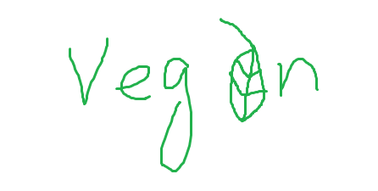

User stories

As a customer

I want to see the company on social media

So that I can see what they advertise.

Acceptance criteria

Given the customer has social media

When they see/add us on it

Then they will see what we have available and what promotions we are running

User stories

As a customer

I want to be able to view the company logo

So that it is displayed on the navbar, webpage tab and footer.

Acceptance criteria

Given the logo is displayed

When they view it/ click it

Then they can be navigated back to the website.

User stories

As a customer

I want to order food online

So that I do not have to get outside my home in such cold weather

Acceptance criteria

Given the user is in our webpage

When user clicks on the items they want to order

Then they can pay online via our secure system and get their order delivered

User stories

As a customer

I want to see a menu

So that i can see if there is anything that i would possibly like and how much something is

Acceptance criteria

Given that the customer sees the menu

When they decide what they think they could like

Then they could order or see if it fits in with their dietary requirements and price range

User stories

As a customer

I want to view the about page,

So that I can see information about the company.

Acceptance criteria

Given there is an about page

When I view this page

Then I would like to have information on the head chef, along with vegan cuisines and a breakdown on veganism.

User stories

As a customer

I want to place reservation

So that I do not have to wait when I arrive to the restaurant

Acceptance criteria

Given that you are in our website

When you navigate to our booking bar on top

Then you can select the date and time then it will show you available tables to place your reservation which you can confirm online.

(You can only book before 1 month)

User stories

As a customer

I want to see the location of the restaurant

So that i can go to it or see if i can order from it

Acceptance criteria

Given that the customer sees where we are located

When they are nearby they will remember

Then they will possibly come in and order something

User stories

As a staff member

I want to be able to delete or update reservations

So that If a customer phones to cancel reservations or update ( specific table or amount of people)

Acceptance criteria

Given there are free tables

When answering a call

Then I can book or delete reservations without any confusion.